What is Knowledge?
Perfesser Plum
Your car has all kinds of parts. These parts must work, and they must work together for your car (the whole thing) to run. Most cars nowadays have a computer in them. This computer makes sure that all the parts work, and work together.
We live in a civilization. Like a car, our civilization has lots of parts. These parts include individual human beings. Human beings work together to produce social institution such as economy, family, medicine, law, education, and so on. Human beings have to know HOW to work together to produce their social institutions and to keep them running. Just as the modern car needs a computer to make it work, human beings need a common stock of KNOWLEDGE to make their civilization work. Civilizations rest on knowledge.
What’s this got to do with education? A lot.
The purpose of education is to transmit knowledge and core values to the next generation so that the next generation can sustain the civilization. If we were a small society---a band of hunter-gatherers, the stock of knowledge could be transmitted (taught) by the whole village, through (1) modeling (“Do it like this, Iggy.”); (2) rituals (“Now you are a woman, Debbie.”); and (3) everyday activities (“Let me tell you kids the story of our people.”). But when a civilization is large, and when a lot of new persons enter the territory as immigrants, then family and neighborhood are not enough. So, we have a special institution---education---that takes over the job of transmitting culture beyond basic knowledge (such as language, respect, activities of daily living) taught by family. Whether our education institution does a good job---and whether it even COULD do a good job given certain undesirable changes in our society---is another question. And, given the easy availability of knowledge and teaching materials of all kinds---it’s possible for many families to provide a high quality education in the home. Still,
whether education is provided in schools or homes or some other place, instruction (communication of knowledge) has to be well-designed.
But what is knowledge? I’ll tell you, one step at a time. Now, as soon you start reading, you’re going to say, “Hey, what’s this? Philosophy? What’s philosophy got to do with education?” Answer: EVERYTHING. Teaching is….wait for it….APPLIED PHILOSOPHY. Specifically, education is the branch of philosophy called epistemology, or in ancient Greek, επιστημολογία. Theory of knowledge---what knowledge is and how we acquire it. Your job isn’t just to move stuff from textbooks into your students’ notebooks and heads by talking at them. It’s much more than that. It is to teach them what knowledge is; what kinds of knowledge there are; and to use the logical steps for examining texts and real-world events, and then figuring out what they mean. To do this, you need to be see yourself as a practical philosopher. So, let’s get to it.
1. Reality. What is it? Reality simply IS. Reality is THAT whose existence does NOT depend on being experienced (witnessed) or interpreted (understood). Reality IS---even if human beings are NOT. Reality IS, no matter what human beings believe. 2 + 2 is 4, even if you say it’s 5. The earth revolves around the sun, even though it LOOKS like the sun revolves around the earth.
2. Knowledge must be about reality---about what IS. If knowledge is NOT about reality---not about what IS---then knowledge would be about what ISN’T, and therefore knowledge would be about NOthing. And that’s just stupid! So, knowledge must be about something. And that something is……..reality.
3. What does it mean to say, “Knowledge is about reality?” About reality? What is the connection between reality and knowledge? Okay, I’ll show you.
Reality The Human Learning Mechanism Knowledge
Uses Logic (Reasoning) to Transform
Raw Experience into…
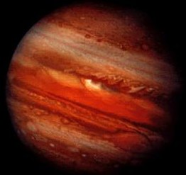 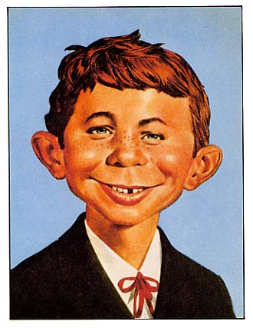
Pretty much all we get from Jupiter is Jupiter is the fifth planet from the Sun and by colors colors and movement. But, with far the largest. Jupiter is more than twice
physics and mathematics, we can as massive as all the other planets combined.
transform the raw experience of color The mass of Jupiter is 318 times that of Earth.
and movement into knowledge---facts
such as those on the right. Diameter: 142, 984 km
Jupiter is the fourth brightest object in the sky (after the Sun, the Moon and Venus).
Jupiter is about 90% hydrogen and
10% helium
Jupiter probably has a core of rocky material
amounting to something like 10 to 15 Earth-
masses. http://nineplanets.org/jupiter.html
Knowledge is a representation of reality. RE-presentation. Look at this. Sunset, clouds, sky, trees. Are these IN your head? Is the sunset in your head?
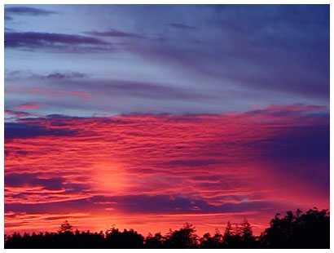
No, the sunset is something (reality) OUT THERE that exists INDEPENDENTLY of you. IT is not in your head. Even if you have a fat head with lots of room. What IS in your head is a representation of the EXTERNAL reality of sunset, sky, clouds, trees. Listen, reality presents itself to your senses as raw experience---color, sound, touch. The picture, above, however, REpresents (presents again) reality to your senses. Likewise, the words “thunder,” “lightning,” “precipitation,” “hail,” “gale force” are not in the stormy sky. They are words used to represent the reality of the storm. They are knowledge OF the storm.
4. There are different ways to represent reality---different mediums. Mediums for what?
Representing ___________________. Let’s look at some of the media for representing reality.
a. Paintings, drawings
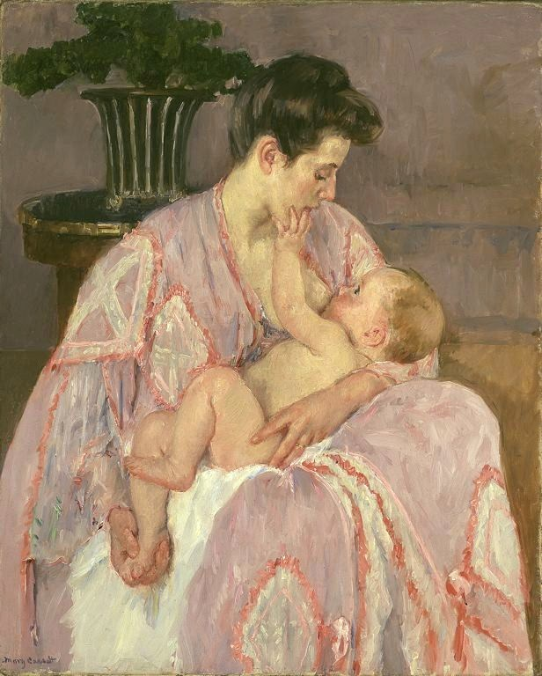
Mary Stevenson Cassatt (……May 22, 1844 – June 14, 1926) was an American painter and printmaker. She lived much of her adult life in France, where she first befriended Edgar Degas and later exhibited among the Impressionists. Cassatt often created images of the social and private lives of women, with particular emphasis on the intimate bonds between mothers and children. http://en.wikipedia.org/wiki/Mary_Cassatt
Mary Cassatt’s painting represents---portrays, communicates about—a REAL mother and child. Clothing. Hair. A table. Nursing. What else in REALITY does it portray? Tenderness? Trust? The most intimate connection in the world? That for which we long? The essence of woman?
If we analyze the painting----if we break it into details, parts, elements and examine each one and how they FIT---we might find out HOW Mary Cassatt was able to represent and then COMMUNICATE this knowledge of reality. How does she represent a translucent fabric? How does she represent tenderness? How does she represent connection? Look at the eyes.
Cassatt arranged colored dots and lines, and the arrangement produces in the viewer the knowledge identified above.
Imagine that there is the slightest deviation from the imaginary line between mother’s and child’s eyes. The painting no longer communicates the mother-infant bond. “The infant is looking at her but she is looking away. Maybe she’s bored.”
Imagine that she is not holding the kid's foot. The painting no longer communicates love and tenderness. “The baby is naked and she’s not even keeping her foot warm.”
***So, whatever knowledge is communicated depends on a selection of colors (so you can see eyes) and the arrangement of elements (colored points)---to depict tenderness, for example.
Now, in what sequence did Cassatt paint this picture? In what sequence did she DESIGN and enact the communication—that is, put brush to canvas? I have it on good authority (from Ethan Vick. Personal communication. January 25, 2011) that she FIRST placed mother and child in the center. Then she chose colors (purple for divinity---the mother as goddess). Then she worked on arm under sleeve, hand on foot, hand on hip, and finally eyes.
Note that this sequence uses LOGIC for designing and enacting the representation of reality. Cassatt could not paint the mother’s clothing until she had painted the body underneath; she could not paint the body until she had decided where to place the figures on the canvas; and she could not paint the eyes (with the imaginary eye-to-eye line communicating bond) until she had placed the heads. In other words, logically, she had to enact the communication in a LOGICAL order. Certain steps logically must come before others.
***So far, when we think of design, we think of (1) selection of colored points (basic knowledge elements); (2) arrangement of colored points (basic knowledge elements) to represent persons, feelings, bond; and (3) a sequence used by the painter for designing and then enacting (painting) the communication.
Note: asking why Mary Cassatt followed a certain (logical) sequence for designing and enacting (painting) her communication about the reality of mother and child, is the same as asking why you follow a certain (logical) sequence for designing and delivering instruction to communicate about the reality of mathematical relations or how mountains are formed. Do you plan instruction by starting (a) with the last lesson, or (b) the first? Do you plan instruction by starting with (a) objectives, and then figure out how to teach knowledge that MEETS the objectives; or, (b) do you first plan how to teach certain kinds of knowledge, and THEN figure out what the objectives of the teaching should be? The answer is “a” both times. Start with final objectives for instruction (what you want students to do when you are finished) and work backwards, always asking, “What do they need to know from earlier lessons (and what do I need to teach in earlier lessons) to learn the current lesson?” Lesson 100 tells you what lesson 99 has to teach. Lesson 99 tells you what lesson 98 has to teach. All the way back to lesson 1.
b. Music.
Listen to these. http://www.youtube.com/watch?v=EM8RlCZP0KQ&feature=related Beethoven. 6th Symphony. Fifth Movement.
http://www.youtube.com/watch?v=ghVAH_WX-9I Iris Dement. Our Town.
http://www.youtube.com/watch?v=fT-aEcPgkuA&feature=related. Stan Rogers.
What knowledge about reality do these pieces of music communicate? What (1) elements (notes, instruments, words, speed, loudness) and sequences of elements (sentences, stanzas, passages) communicate the information.
c. Dance.
http://www.youtube.com/watch?v=jNeIMzrCXnQ&feature=related See especially at time 3:43. What knowledge of reality---physical or human or divine---does this communicate?
d. Poetry and prose.
They Are Not Long
THEY are not long, the weeping and the laughter,
Love and desire and hate:
I think they have no portion in us after
We pass the gate.

They are not long, the days of wine and roses:
Out of a misty dream
Our path emerges for awhile, then closes
Within a dream.
[Ernest Dowson]

These words are talking about reality. They are representing it. What are they representing? THAT is the meaning of the poem? The words represent (they mean, signify, point to) some reality.
Another poem. Notice the difference between seeing the poem and hearing it.
http://www.youtube.com/watch?v=WhQwFf6Qb9U Gerard Manley Hopkins.
THE LEADEN ECHO
HOW to kéep—is there ány any, is there none such, nowhere known some, bow or brooch or braid or brace, láce, latch or catch or key to keep
Back beauty, keep it, beauty, beauty, beauty, … from vanishing away?
Ó is there no frowning of these wrinkles, rankéd wrinkles deep,
Dówn? no waving off of these most mournful messengers, still messengers, sad and stealing messengers of grey?
No there ’s none, there ’s none, O no there ’s none, | 5
Nor can you long be, what you now are, called fair,
Do what you may do, what, do what you may,
And wisdom is early to despair:
Be beginning; since, no, nothing can be done
To keep at bay | 10
Age and age’s evils, hoar hair,
Ruck and wrinkle, drooping, dying, death’s worst, winding sheets, tombs and worms and tumbling to decay;
So be beginning, be beginning to despair.
O there ’s none; no no no there ’s none:
Be beginning to despair, to despair, | 15
Despair, despair, despair, despair.
THE GOLDEN ECHO
Spare!
There ís one, yes I have one (Hush there!);
Only not within seeing of the sun,
Not within the singeing of the strong sun, | 20
Tall sun’s tingeing, or treacherous the tainting of the earth’s air,
Somewhere elsewhere there is ah well where! one,
Oné. Yes I can tell such a key, I do know such a place,
Where whatever’s prized and passes of us, everything that ’s fresh and fast flying of us, seems to us sweet of us and swiftly away with, done away with, undone,
Undone, done with, soon done with, and yet dearly and dangerously sweet | 25
Of us, the wimpled-water-dimpled, not-by-morning-matchèd face,
The flower of beauty, fleece of beauty, too too apt to, ah! to fleet,
Never fleets móre, fastened with the tenderest truth
To its own best being and its loveliness of youth: it is an everlastingness of, O it is an all youth!
Come then, your ways and airs and looks, locks, maiden gear, gallantry and gaiety and grace, | 30
Winning ways, airs innocent, maiden manners, sweet looks, loose locks, long locks, lovelocks, gaygear, going gallant, girlgrace—
Resign them, sign them, seal them, send them, motion them with breath,
And with sighs soaring, soaring síghs deliver
Them; beauty-in-the-ghost, deliver it, early now, long before death
Give beauty back, beauty, beauty, beauty, back to God, beauty’s self and beauty’s giver. | 35
See; not a hair is, not an eyelash, not the least lash lost; every hair
Is, hair of the head, numbered.
Nay, what we had lighthanded left in surly the mere mould
Will have waked and have waxed and have walked with the wind what while we slept,
This side, that side hurling a heavyheaded hundredfold | 40
What while we, while we slumbered.
O then, weary then why
When the thing we freely fórfeit is kept with fonder a care,
Fonder a care kept than we could have kept it, kept
Far with fonder a care (and we, we should have lost it) finer, fonder | 45
A care kept.—Where kept? Do but tell us where kept, where.—
Yonder.—What high as that! We follow, now we follow.—Yonder, yes yonder, yonder,
Yonder.
Here’s paragraph 2 of the Declaration of Independence.
We hold these truths to be self-evident, that all men are created equal, that they are endowed by their Creator with certain unalienable Rights, that among these are Life, Liberty and the pursuit of Happiness. — That to secure these rights, Governments are instituted among Men, deriving their just powers from the consent of the governed, — That whenever any Form of Government becomes destructive of these ends, it is the Right of the People to alter or to abolish it, and to institute new Government, laying its foundation on such principles and organizing its powers in such form, as to them shall seem most likely to effect their Safety and Happiness. [Thomas Jefferson. First author. Paragraph 2. Declaration of Independence. July, 1776. ]

5. The painter, the composer, the poet, the choreographer, and the writer must design the communication (how they will represent reality) and enact their design (that is, paint the picture, sing the song, read the poem, write the document) in a certain way---LOGICAL---or else the message will not be seen or properly understood. They have to select the right elements (words, examples) and arrange them into sequences (steps, statements, logical arguments)
Let’s compare the portion of the Declaration to Cassatt’s painting of mother and infant. We saw that she used colored points to represent (communicate knowledge of) the superficial reality of clothing, a mother sitting, an infant in the mother’s lap, a table, a plant, and nursing. She also used these colored points to represent (communicate) the more profound realities of love, tenderness, and the intimate and perhaps cosmic bond between Mother and Child. She did this by (1) selecting and arranging colored points; and (2) following a logical sequence for designing and enacting the communication---putting brush to canvas. That is, she had to paint certain things (the location of mother and infant on the canvas) before she could paint other things (an imaginary line connecting their eyes).
Now look at what Jefferson did.
Jefferson is communicating a theory of representative government.
This theory is really a logical argument (a case being made) for the right of revolution.
As with Cassatt, all he has to work with are small black figures (basic elements of written communication, or representation)---ink on paper.
He arranges the basic element of letters (u, n, a, l, i, e…)
a. Into a longer sequence of words (“unalienable”) that he has selected.
b. He arranges the words into longer sequences of statements (assertions that have a subject and predicate). “…they are endowed by their Creator with certain unalienable Rights.”) in sentences. [Some sentences contain several statements.]
c. He arranges the sentences into an argument (a logically connected sequence of statements leading to a conclusion statement)---all to communicate about the reality of human rights and government.
Notice the word choice (similar to Cassatt’s color choices). He says, “endowed by their Creator with certain unalienable rights...” He could have said, “they have certain unalienable rights.” Adding Creator gives weight to the rule about humans having unalienable rights.
He said, “We hold these truths to be self-evident.” He could have said, “We believe the following are pretty clear.” Again, these words add weight or force to the rule that what come next are truths.
He said “unalienable rights.” He could have just said “rights.” The use of “unalienable” adds force to the rule--“….endowed by the Creator with certain unalienable rights…” Meaning, they can’t be taken away. They are not up for discussion. They come with being human.
Now look at the arrangement of statements. He begins by saying that everything that comes next is a self-evident truth. Pretty strong. Then he asserts a general rule about rights (an example of a self-evident truth); then says what these rights are; then says governments are instituted to protect these rights; and then ends (concludes) by saying that when governments don’t protect these rights, the People have the right to alter or abolish the government. Each next statement follows from the earlier. Do you see that the final statement (the conclusion that he was working towards all along) follows logically from the ones before? You can’t resist the truth of the final statement about revolution. If everything he said before---every statement ---is true (and he said that everything was a self-evident truth), then the conclusion (right of revolution) MUST also be true.
Imagine that he arranged the sequence of statements differently. Imagine that the last line was, “Oh, and we think these truths are self-evident. “ That would have little force. It would NOT come off as truth, but as opinion.
Imagine that he did NOT begin by stating that all human beings equally have certain rights, but ENDED with that. That would sound weird. Not logical. “Where did THAT come from?
***So, as with Cassatt’s painting, the selection and arrangement (ordering) of elements (letters to make words, words to make statements in sentences, arranged into an argument in a paragraph) is all.
Isn’t it true that these arrangements have the quality of perfection? They are “logically faultless.” And for that reason, they communicate knowledge easily and quickly and unambiguously. You don’t have to think about what Cassatt is telling you about mothers and nurturing, the nature of women, etc. It’s EXPLICIT. And you don’t have to think hard about where Jefferson got the conclusion that People have the right to alter or abolish their government. It follows logically from the way he arranged the statements.
Now, if you please, go to this document.

